A000-Mex-Nayarit-Figure-Male with Headdress-striped-Terra cotta-200 BCE-200 CE

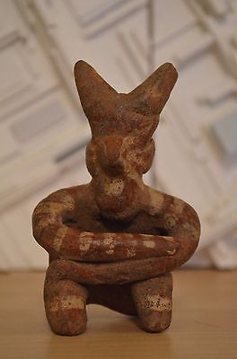

#### [Pre-Columbian Nayarit Mexico Tomb Figure Ixtlan del Rio 200 BC - AD 250](http://www.ebay.com/itm/151878374925)